On tour this October with audio described shows and touch tours for the low vision community.
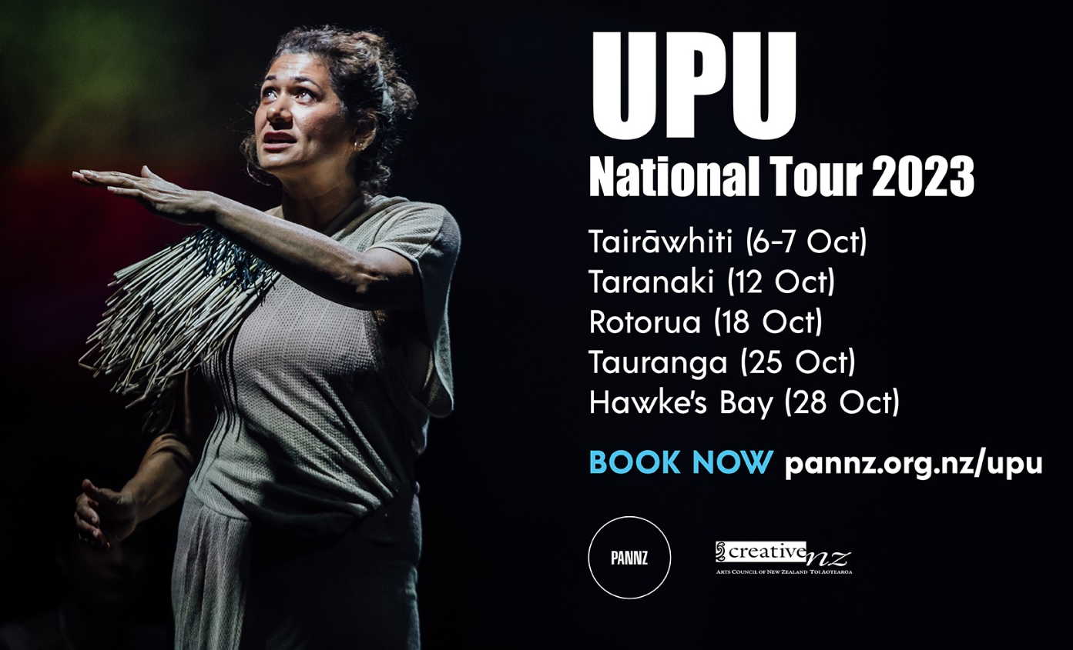

Experience the trailer: https://www.youtube.com/watch?V=htprxxsae1k
Get behind the scenes insights from the cast: https://youtu.be/PK46HbCWyFY

The Performing Arts Network of New Zealand (PANNZ) and UPU Collective present
UPU
Following critical acclaim as a major new production for Silo Theatre in the 2020 Auckland International Arts festival, and a sell-out season in Wellington at the Kia Mau Arts Festival in 2021, the award-winning UPU will be presented across Aotearoa in October 2023 as part of PANNZ's touring programme.

“IN SHORT, UPU SHOWS OCEANIC STORYTELLING IS TRULY AMAZING” - NZ HERALD

The power of Māori & Pasifika literature roaring to theatrical life.
The world of Oceania is not small. From the energetic volcanoes of O’ahu to the southern reaches of Aotearoa, she is borderless and vast – and growing bigger by the day. After decades of dismissal and disconnection, her children are closer than ever. It’s time for a reunion.
In Samoan “upu” means “word”.
Curated by award-winning poet Grace Iwashita-Taylor and led by powerhouse director Fasitua Amosa, UPU gives the stage to Oceania’s most electrifying poetry. Ben Brown, Karlo Mila, Albert Wendt and more: UPU is for the trailblazers, the icons and the new writers transforming Aotearoa today.
In UPU, borders disappear and for just over an hour, the theatre becomes a sea of Islands. Be transported across an ocean to hear the voices dealing with colonisation, family, climate change, love, sex, religion, power and tourists.
Performed by a stellar cast of some of the best Tagata Moana actors in Aotearoa NZ - Maiava Nathaniel Lees, Mia Blake, Ana Corbett, Shadon Meredith, James Maeva, Nicola Kāwana and Nora Aati.

“THIS SHOW IS PURE ORATORY AND STORYTELLING AT ITS FINEST.” - THEATRESCENES (NZ)

Supported by Creative New Zealand, produced by UPU Collective and presented as part of the PANNZ (Performing Arts Network New Zealand) touring programme.

Recommended for ages 15+. Contains strong language and adult themes.

PANNZ are delighted to be partnering once again with Audio Described Aotearoa, supported by Manatū Taonga Ministry of Culture and Heritage, to offer touch tours and audio described (AD) performances of UPU for the low vision community in Taranaki, Rotorua, Tauranga and the Hawke’s Bay. Full booking details for the AD performances will be listed on the booking websites once available.

LOCATIONS, DATES AND TICKETS
Taranaki, REIMAGINE FESTIVAL

Venue: Theatre Royal, TSB Showplace
Date: Thursday 12 October
Time: 6.30pm Touch Tour, 7.30pm Performance
Performance duration: 60 minutes (no interval)
To Book: Contact the Festival team on 06 759 8412 or email events@taft.co.nz
Tickets from $45 (A complimentary companion ticket is available when booking.)

Rotorua
Venue: Sir Owen Glenn Matangi Rau at Sir Howard Morrison Centre
Date: Wednesday 18 October
Time: 6pm Touch Tour, 7pm Performance
Performance duration: 60 minutes (no interval)
To Book: Phone 07 351 8094 or email SHMCrequests@rotorualc.nz
Tickets from $25 (A complimentary companion ticket is available when booking.)

Tauranga, Tauranga Arts Festival
Venue: Addison Theatre, Baycourt Community & Arts Centre
Date: Wednesday, 25th October
Time: 5.30 Touch Tour, 6.30pm Performance
Performance duration: 60 minutes (no interval)
To Book: phone 0212254560 or email access@taurangafestival.co.nz
Tickets from $20 (A complimentary companion ticket is available when booking.)

Hawke’s Bay, Hawke’s Bay Arts Festival
Venue: Opera House, Toitoi Hawke's Bay Arts & Events Centre
Date: Saturday, 28 October
Time: 6pm Touch Tour, 7pm Performance
Performance duration: 60 minutes (no interval)
Tickets from $25 (A complimentary companion ticket is available when booking.)
To Book: Phone Toitoi Hawke's Bay Arts & Events Centre box office on 06 877 9600. or email accessibility@toitoivenues.co.nz

